**Q1. Is an assignment operator like += only for show? Is it possible that it would lead to faster results at the runtime?**

**Ans: A=A+1** evaluates to finding A, adding 1 to it. Then storing the value again in variable A. This expression makes Python to look for memory holder of a twice. But A+=1 simply means value of A is to incremented by 1. As memory address has to be identified once, += leads to faster operation.

**Q2. What is the smallest number of statements you'd have to write in most programming languages to replace the Python expression a, b = a + b, a?**

**Ans:**  Minimum number of lines required to write above code in languages other Python will be 4, two for assigning initial values for variables a and b, and two for reassignment i.e. a=a+b and b=a.

**Q3. In Python, what is the most effective way to set a list of 100 integers to 0?**

**Ans:** The Most effective way to set a list of 100 integers to 0 in python is by using repition operator(*) or by using list comprehension.

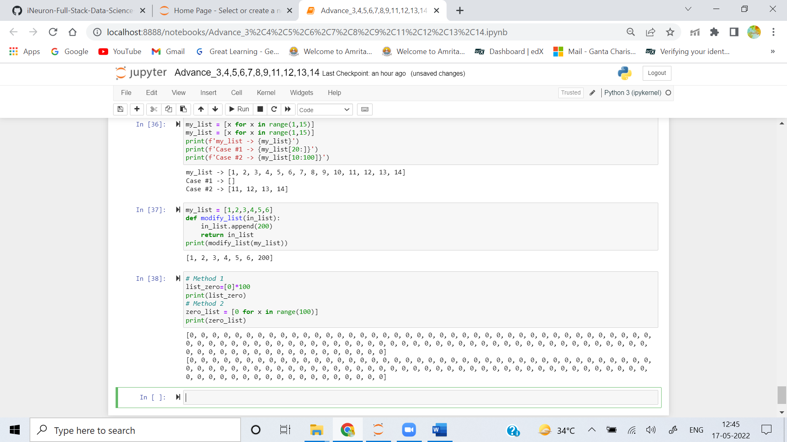

**Q4. What is the most effective way to initialise a list of 99 integers that repeats the sequence 1, 2, 3? S If necessary, show step-by-step instructions on how to accomplish this.**

**Ans:** 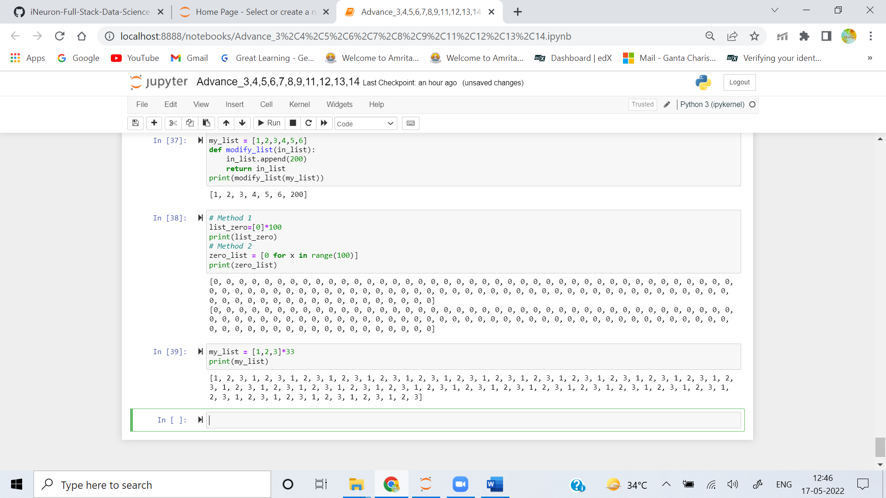

**Q5. If you're using IDLE to run a Python application, explain how to print a multidimensional list as efficiently?**

**Ans:** 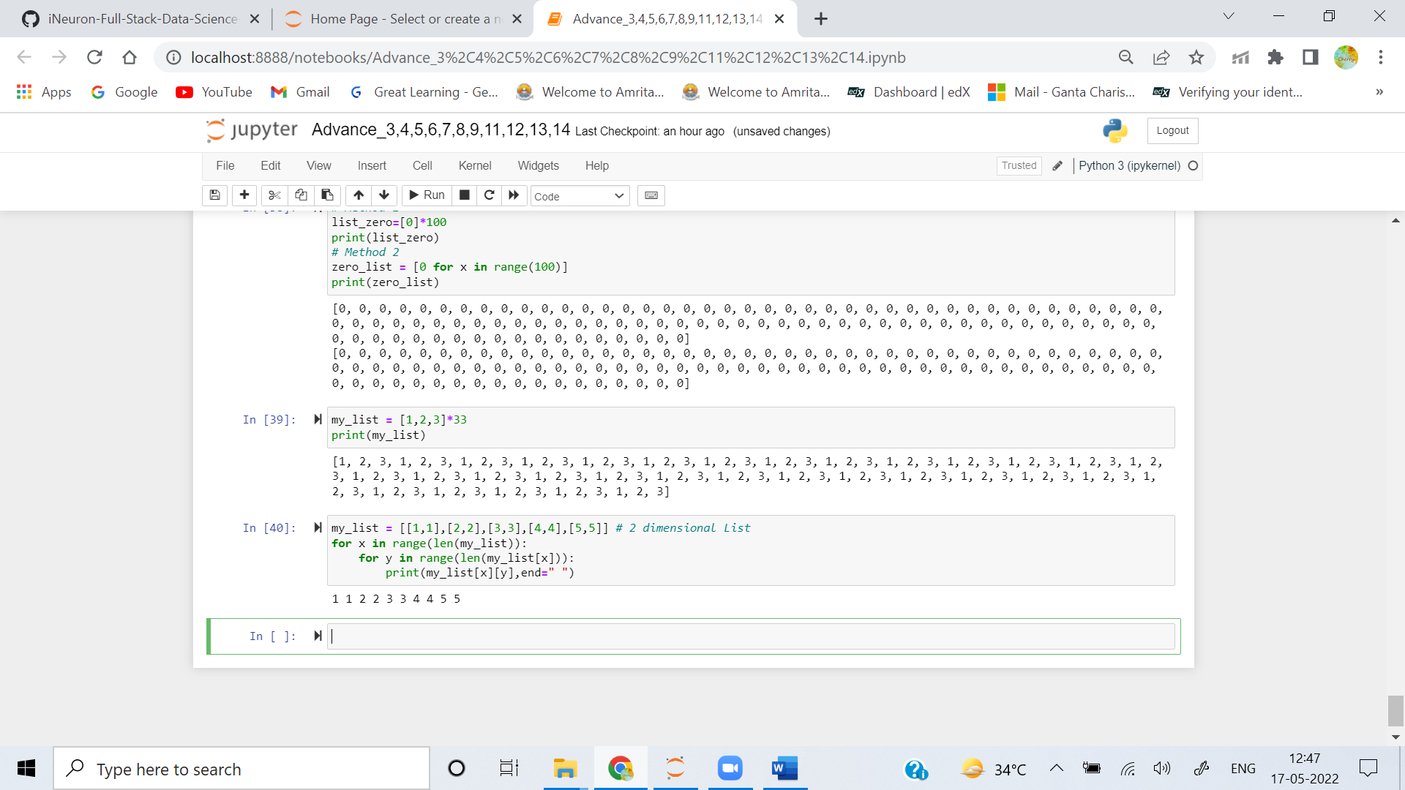

**Q6. Is it possible to use list comprehension with a string? If so, how can you go about doing it?**

**Ans:** List comprehension with string is possible.

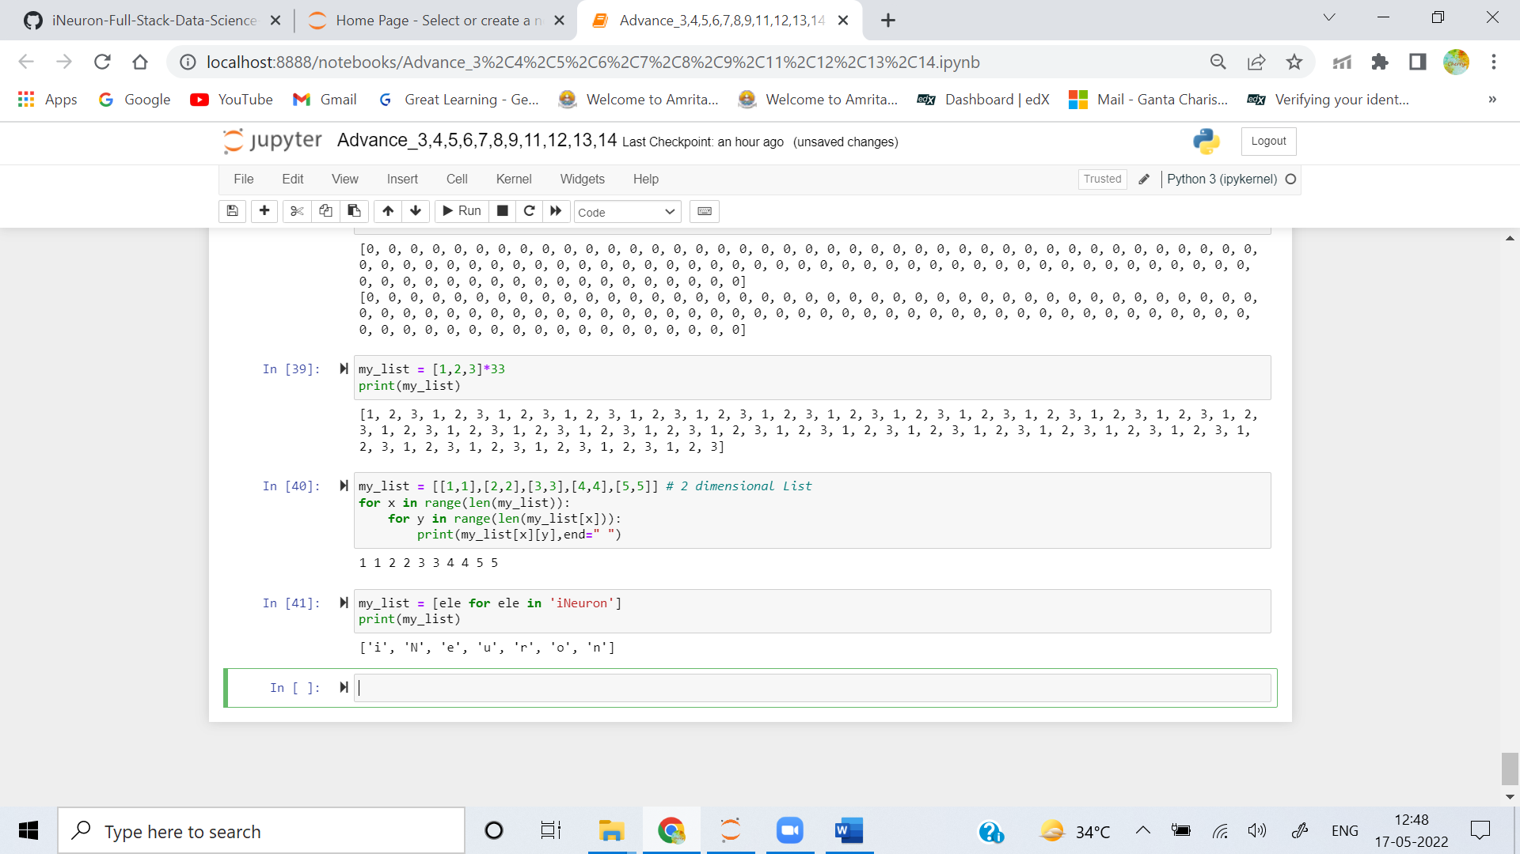

**Q7. From the command line, how do you get support with a user-written Python programme? Is this possible from inside IDLE?**

**Ans:** **Get support with a user-written Python Programme:** Start a command prompt (Windows) or terminal window (Linux/Mac). If the current working directory is the same as the location in which you saved the file, you can simply specify the filename as a command-line argument to the Python interpreter.

**Get support with a User-written Python Program from IDLE:** You can also create script files and run them in IDLE. From the Shell window menu, select **File → New File**. That should open an additional editing window. Type in the code to be executed. From the menu in that window, **select File → Save or File → Save As…** and save the file to disk. Then **select Run → Run Module**. The output should appear back in the interpreter

**Q8. Functions are said to be “first-class objects” in Python but not in most other languages, such as C++ or Java. What can you do in Python with a function (callable object) that you can't do in C or C++?**

**Ans:** The tasks which can be performed with the functions in python are:

* A function is an instance of the Object type.
* You can store the function in a variable.
* You can pass the function as a parameter to another function.
* You can return the function from a function.
* You can store them in data structures such as hash tables, lists,

**Q9. How do you distinguish between a wrapper, a wrapped feature, and a decorator?**

**Ans:** Wrappers Around the functions are known as Decorators.

**Q10. If a function is a generator function, what does it return?**

**Ans:** Generator functions are a special kind of function that return a **lazy iterator**. These are objects that you can loop over like a list. However, unlike lists, lazy iterators do not store their contents in memory.

**Q11. What is the one improvement that must be made to a function in order for it to become a generator function in the Python language?**

**Ans:** Generator is a written as normal function but uses **yield** keyword to return values instead of **return** keyword.

**Q12. Identify at least one benefit of generators.**

**Ans:**  **return** statement sends a specified value back to its caller whereas **yield** statement can produce a sequence of values. We should use generator when we want to iterate over a sequence, but don’t want to store the entire sequence in memory.